Jews Gone Wild

Take a handful of heebs, a flotilla of food and a barge of booze, and what do you get? A ton of fun. Six of us set out on the sunny Caribbean in May 2008.

Let’s start at the author’s point of departure. My girlfriend Traci and I arrived at Baltimore-Washington International Airport on May 2nd. We went through the X-ray machine as the airport security folks chanted “Take it all off!” to Traci. After she got dressed they stuffed dollar bills in her skirt. We had a nice flight, except for our mean steward -- oh, excuse me, flight attendant (like there’s a friggin’ difference). When I asked him what kind of juice was available, he said, “There’s a menu in the in-flight magazine.” For an instant I considered sticking the magazine in a very dark place, but considering what this guy did for a living, I figured he was being punished enough.

Upon arriving at Debbie’s house we started eating immediately, because it is an unwritten law that when you visit her, you must figure out how much food would make your stomach explode, and eat one ounce less than that.

In the evening Marge, Doug, Debbie, Traci and I went to Gary Woo’s Asian Bistro for a surprise celebration of Debbie’s 70th birthday, which was the reason we were going on a cruise in the first place. Twenty-eight of us feasted on spectacular food as we commemorated Debbie’s milestone. Many of the guests were transplants from our old neighborhood in Newton MA, because under Massachusetts law, all Jews must eventually move to Florida. After dinner the five of us plus Marge’s childhood friends Dot and Deb returned to Debbie’s to sample my homemade beer. After Dot and Deb left the rest of us stayed up and did a midnight toast as the date turned to Debbie’s actual birthday, May 3rd.

In the morning Traci and I worked out at the gym, and then we all had a big lunch just before going to
Port Everglades, because God forbid we should take an all-you-can-eat cruise on an empty stomach. Traci and I sneaked some wine in our luggage on the advice of our Brooklyn-bred van driver John, who told us, “Dey never check.” So much for the strict no-alcohol-in-your-luggage policy. Later she and I would skip the ship’s mandatory lifeboat drill, choosing instead to engage in carnal acts that are still illegal in nine states.

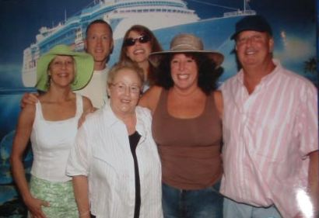

Here we all are as we embarked on Royal Caribbean’s Enchantment of the Seas. That’s me and Patty in back, and Traci, Debbie, Marge and Doug in front. That’s not the actual ship behind us – it’s a mural that the photographer had us stand in front of. We all looked pretty much the same at the end of the cruise, except that we gained a total of 873 pounds.

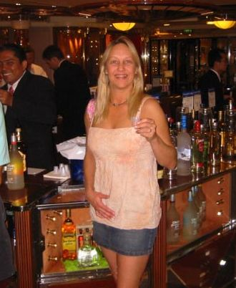

The first thing we did after checking into our room was eat. The Windjammer Café had so much food we didn’t know where to begin. Then we went to the pool, where just about every chaise longue was taken. There was a surprisingly large percentage of young folks and children on the cruise. Later Traci and I went to a free booze tasting that featured rums, vodkas and liqueurs (there she is enjoying some in the photo). We met two passengers from Belgium there, so naturally I discussed beer with them.

After the booze tasting, Traci and I went to the champagne bar for a glass of champagne. Wines were priced at up to $19 a glass. I tell you, it’s not cheap being an alcoholic. Then we all went for dinner in the elegant My Fair Lady dining room, where we pigged out. All the waitstaff were very nice to us even though we probably consumed more food in one sitting than their entire villages ate in a month.

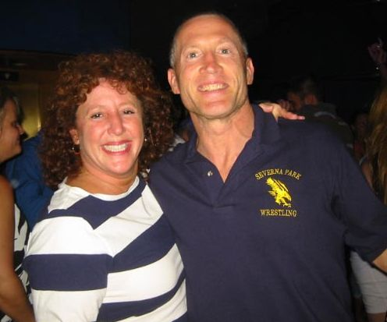
After dinner Traci and I went to the Viking Crown Lounge discotheque to dance. It was just like when I used to go out 25 years earlier, except this time I was dancing with an actual woman. Marge and Doug joined us for a while. Afterward Traci and I went to the Solarium, a glass-enclosed pool area where kids are not allowed. It’s a nice quiet getaway, and it features a hotdog/hamburger bar that lasts into the wee hours for those passengers who don’t get quite enough cholesterol during the day.

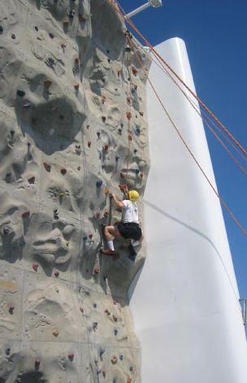
Sunday May 4th. Traci and I noticed that we could hardly feel the ship moving during the night, which is good because I do not do well on boats. One time I went fishing after a blueberry pancake breakfast, and I left a purple chum slick that is still visible from space. Anyway, we went for a nice breakfast in the dining room, then went to the Windjammer for breakfast number two. (Heh heh. I said “number two”.) Then, armed with lots of carbs and protein, I went to the rock climbing wall. It had three climbing areas with varying levels of difficulty. I climbed the easy and medium parts easily. On the difficult part I got about a third of the way up before my forearms bloated to the point where I looked like Popeye. I could no longer work my hands or grip anything. Good thing Traci was with me or my sex life would have been ruined.

We walked through the fitness room, which was heavily used. Traci and I didn’t use it as we were on the ship to gain calories, not use them. The ship also had a jogging track, a shuffleboard court, and a ping pong table. There was a ping pong tournament, which Doug won. Quite handily, I might add. In fact, he beat one opponent so badly that she nearly fell out of her wheelchair.

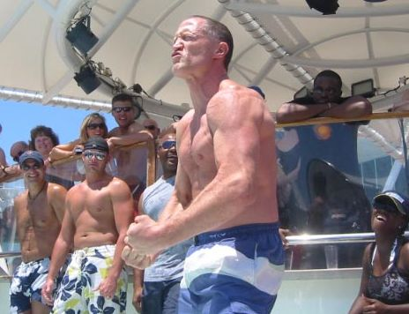
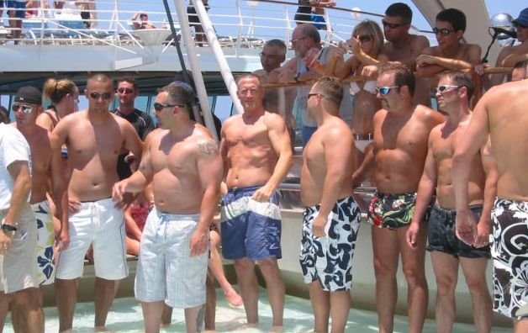
Every chaise longue by the pool had either a person or a towel on it (or both). We managed to finagle a few chaise longues with abandoned towels so we could sit in the sun and get cancer like everyone else. They had a women’s hula hoop contest, which Traci entered. She kept that hoop on her hips for about as long as your economic stimulus check will pay your mortgage, but she looked great doing it. Immediately after the contest, the three winners got to judge the Mr. Enchantment of the Seas contest, where 13 guys (of which I was the oldest) danced and flexed in an attempt to woo the judges. I managed to come in third. Or, as the announcer said in his Turkish accent, “turd”. I’ve been called worse. Anyway, it turned out that the guys who placed ahead of me were each with one of the judges. In fact, one of them proposed to his fiancée in the dining room in front of everyone a few nights later. About seven people came up to me during the remainder of the cruise to say that I should have won, but it didn’t matter since all three places got the same prize: a Royal Caribbean medal. And that was the best prize of any contest on the ship. For example, when we won the Name That Disco Tune contest a few hours later, the prize was a friggin’ Royal Caribbean keychain.

That night I ate 3 appetizers, 3 entrees and 2 desserts. After a nap, Traci and I caught the last two singers in the Karaoke hour, then went to the disco where five crew members dressed up like the Village People and put on a great show as they danced to that 70s group’s music. Debbie joined us, making her the coolest 70-year-old on the ship.
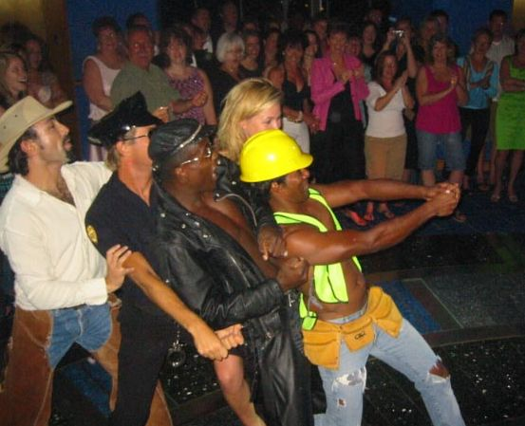
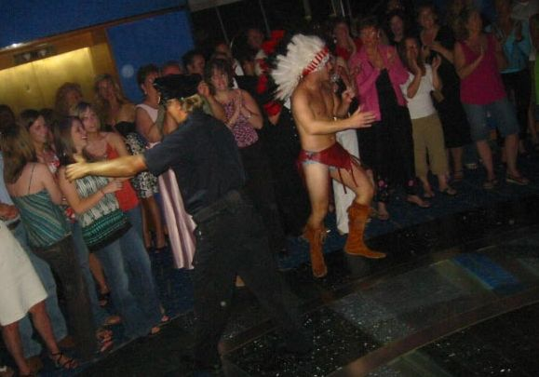

Monday May 5th. I ate two breakfasts again, and all six of us disembarked to Georgetown, Grand Cayman. It’s an expensive, British-owned island where they drive on the left. For all the hoopla you’d think that it wouldn’t look like a 3rd world country, but it does. It’s noisy and congested and polluted. And it smells. In fact, it smells so bad that they named one part of it Hog Sty Bay. But at least you get to pay too much for food and jewelry, so it’s got that going for it. And all the products are duty-free, which means they have no doody in them.
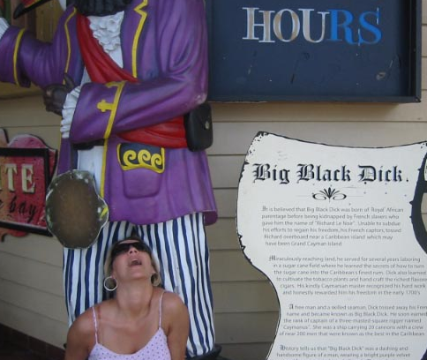
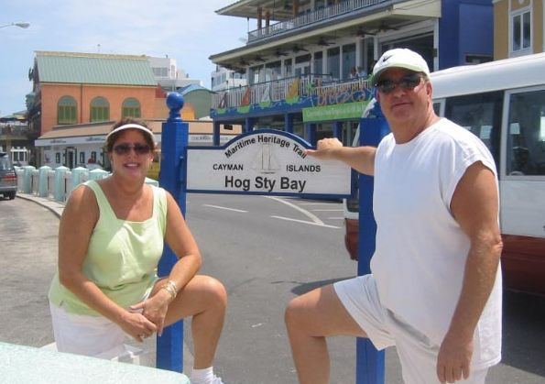

Traci cavorting with the local celebrity.
See? I told you.

After browsing in a few useless shops we split up. Debbie and Patty returned to the ship while the four “kids” stayed on the island. Traci and I got a cab to Seven Mile Beach. It had beautiful, fine sand and clear blue water where you could see the bottom. (Heh heh. I said “bottom”.) The entire beach is public. We swam for a while, then we lay (laid? either way it’s funny) on the beach. It was not at all crowded. In fact, no one was lying near us, and people walked by only occasionally. So my tip for visiting this or any other touristy island is to get the hell away from the shops and hit the beach.
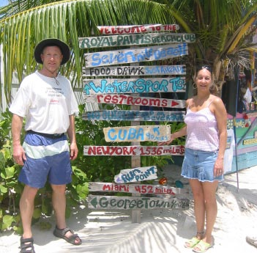
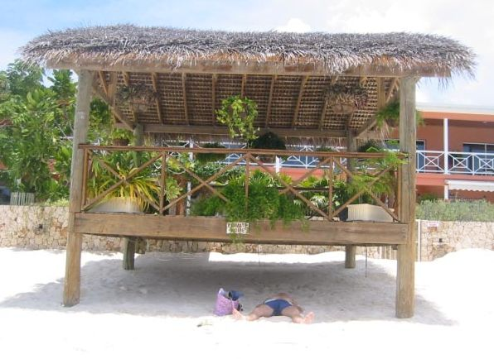

Ben avoiding cancer.
“Which way do we go?”

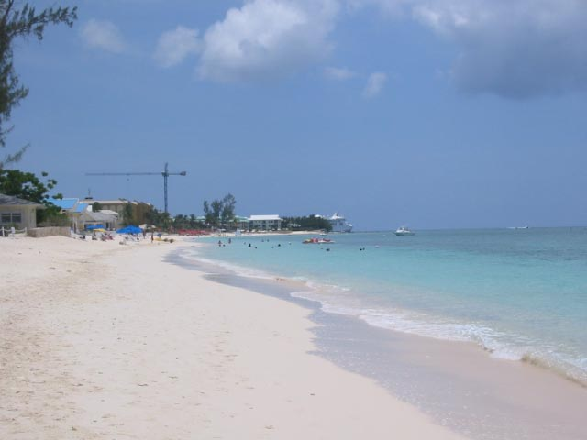
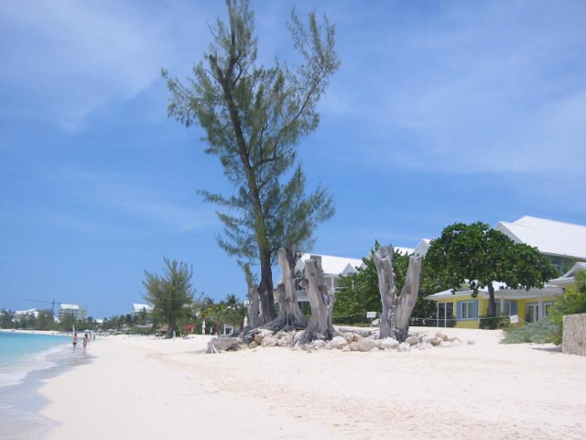
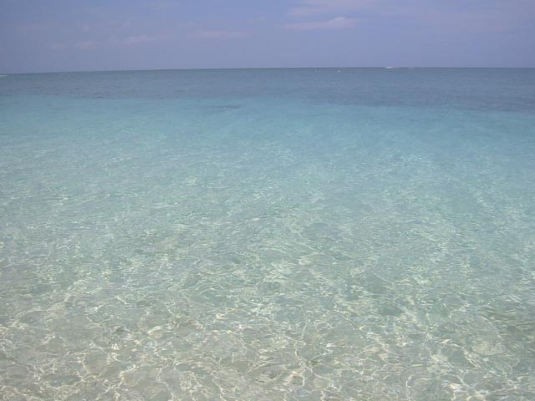

We took a cab back into town. We learned that this small nation has no income, property or sales tax. At the time, gas cost $4.65 Cayman ($5.81 U.S.) per gallon. We saw lots of U.S. businesses: Kentucky Fried Chicken, Subway, Pizza Hut, Burger King, Dairy Queen, Papa John’s and Wendy’s. I spotted a brewpub called Hammerhead’s, so upon leaving the cab I ran in to ask if we could get a tour. They said yes. We retrieved Marge and Doug from Jimmy Buffet’s Margaritaville, where Budweiser was $6.50 a bottle, and the four of us got a great tour of Hammerhead’s from the manager. They’ve been in business for 10 years and use the same yeast over and over. They had been making 3 kinds of beer: a light lager, a wheat beer and a Scotch ale, but they planned to shift to making just the lager. Most of the beer is filtered, and all of it is kegged before being served (it would be expensive to run glycol-cooled lines from a serving tank). They also distill rum, and they age it in the ocean. They claim to be the first distillery that ages their product under saltwater. Unfortunately they were not set to start selling their rum until the following month. It is a single location, and its small, earthy (i.e., not immaculate) appearance was very reminiscent of a Belgian brewery. After the tour we sampled the two beers they had (they were out of the Scotch ale) and ordered a few tequila shots. The lager, called Cali Light, had a nice malty aroma; a nice semi-malty, clean flavor with no bitterness; and a refreshing, hoppy aftertaste. The wheat beer, called Sunset Wheat, was unfiltered. It was good and clean, with no bitterness. It was darker and maltier than the first beer. This place was a gold nugget among the island turds, and of course there was no mention of it in the cruise brochure because even people paying $10 a glass for a good mixed drink or wine don’t give a shit about good beer.
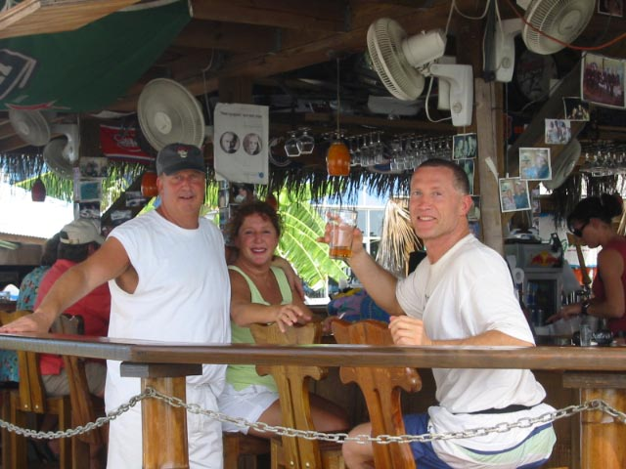
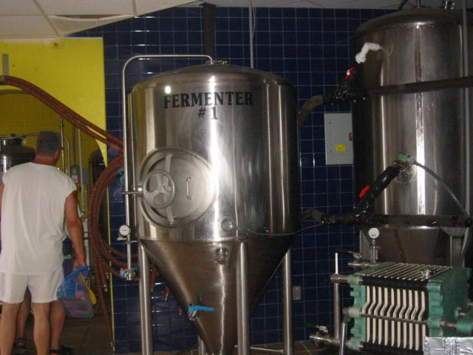
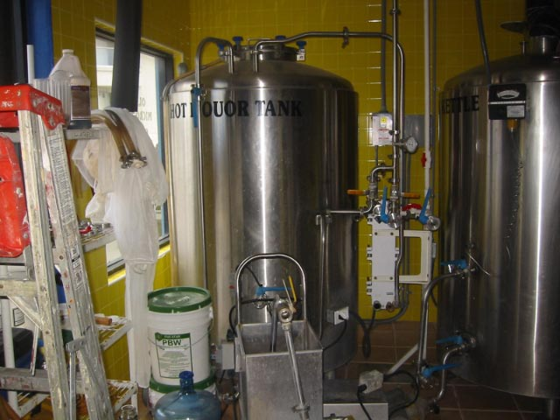

Before boarding the ship we bought a bottle of mango-flavored rum and sneaked it on board. We ate a big buffet lunch, swam and napped. We were soooo tired when we woke up. I’m sure the rum had something to do with it.

At dinner we learned that of the 800+ crew serving the 2400 guests, 100 were cooks, 78 were waiters and 78 were assistant waiters. I can’t say enough about the food and service. For example, our waitress (we sat at the same table and had the same waitress every night) remembered that I had ordered extra spinach the night before, so this night she brought me extra spinach without my even asking.
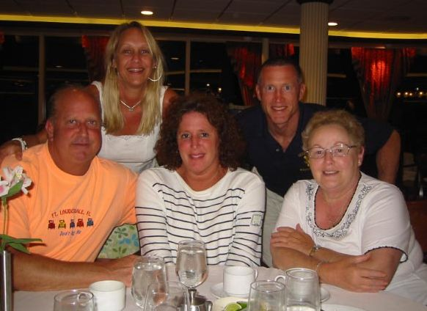
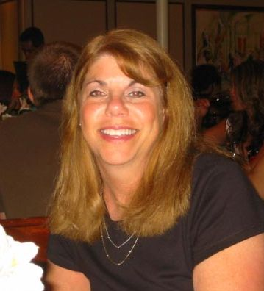

Five...
...plus one.

After dinner we went to the pool deck for dancing under the stars. There was a buffet to pack more food into our bellies in case we hadn’t gorged ourselves quite enough an hour earlier. We ate shrimp, sushi and other stuff, and saw an ice sculpture demonstration. We did some line dances, which were fun except the announcer – a young English woman – had a loud, screechy voice that could peel paint. I wanted to yell at her to shut up but my mouth was full of shrimp.

Tuesday May 6th. After breakfast Traci and I went snorkeling on Cozumel. We were in a group with about 16 other tourists, one of which I thought must have been planted by Candid Camera because no one could actually be that annoying and stupid. As the guide was talking to us before we walked to the snorkeling site, this woman interrupted with, “What? I wasn’t listening – I was looking for my ticket.” When the guide said that we’d start in shallow water and gradually go deeper, she said, “I only want to go in shallow water.” What a noodge. “Then don’t go!” I helpfully added. Later, as the guide led us up some stairs, she asked, “Are we going up?” Then she mentioned to her friend that she had “almost died” the last time she snorkeled, which begged the obvious question of why she would go again. Well, a lot of people repeat their mistakes. After all, both Clinton and Bush got re-elected.

After getting a crash course in how to operate a mask and flippers, we swam against the current in the shallow water. We saw lots of small fish. The guide dived and brought up a small puffer fish. There was a cameraman with us, being followed by a bunch of fish. Turns out he was feeding them tortillas to make them follow him. A few of them actually ate out of his hand. Someone in our group said that in Greece he saw them feed the fish Cheez Whiz. If the Cozumelian fish ever learn that, there goes Cozumel’s snorkeling business. (“Hey Bob, let’s go to Greece – I hear they have Cheez Whiz.”) We went out to deeper water and rode the current back to the starting point. We saw a stingray and some beautifully colored fish. Eventually our bodies cooled down so we got out and returned to the ship.

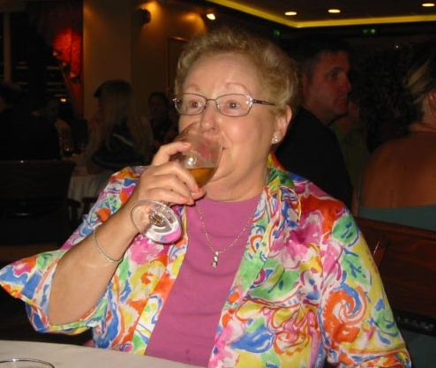
The Windjammer and the pool were not crowded because a lot of people were still on the island. It was a partly cloudy day, but when the sun came out the heat was brutal. Later on Traci and I jumped on the bungee trampoline. They way it works is you’re harnessed to bungee cords that help lift you so you can jump very high. It was a somewhat frightening experience for both of us, jumping way above the ship, looking out at Cozumel, feeling as though we were going to fall right over the side. I did a few flips, which was both exhilarating and nauseating. Later we watched a comedian and had another great dinner. I forget what we did after dinner, but I’m sure it was fun.
Debbie ... drinking?

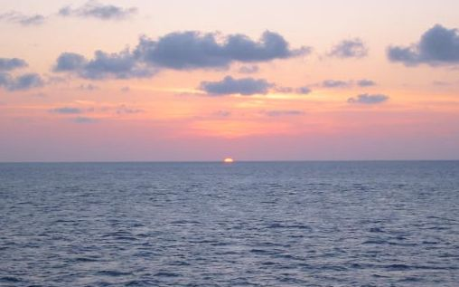
Wednesday May 7th. Our last full day on the ship. After two breakfasts I tackled the difficult part of the rock climbing wall, this time getting a little more than halfway up. We all sunned and shvitzed by the pool for a while, then had lunch in the dining room instead of the buffet for a change. After that Traci and I took a much-needed nap. Before dinner we saw former Olympic gymnast Lance Ringnald put on a great show with not only acrobatics but also juggling, piano playing, and singing. Then we went outside and saw a spectacular sunset.

We had our Last Supper of lobster, steak and other goodies. After dinner we packed because we had to put our checked luggage in the hall before midnight. For some reason, Traci and I decided to put our bag in the hall while we were both naked. She looked in the hall, saw no one, and attempted to lift the heavy piece of luggage out of the room. I went to help, and as I did, someone walked by, noticing the two of us crouching over in a futile attempt to hide our naked bodies. After he passed we heard him say, “Showtime!”

We went to the Spotlight Lounge to hear an hour of bad Karaoke. The drink menu listed a Belgian beer called “Royal”, which is brewed specially for Royal Caribbean. I knew it would be swill, but we ordered it anyway just so we could say we tried it. Not only was it swill, but also the brewery that made it was too embarrassed to put its name on the label. A Web search revealed the brewery to be Palm, which is basically the Coors of Belgium. Afterward we went to the disco for a farewell dance party. Well, the theme must have been farewell to talent, because the music was all rap crap.

By the way, almost every night the woman who cleaned our room would fold towels into animals.
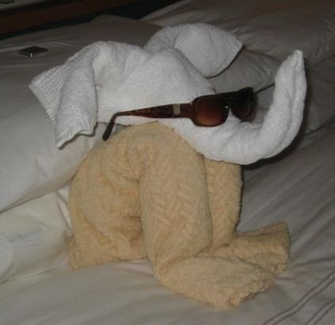
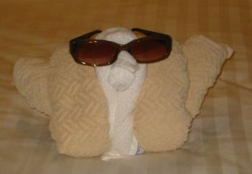
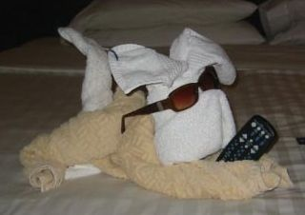
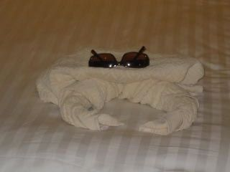

Thursday May 8. We had our last meal, stuffing ourselves one more time before returning to civilization. I must’ve eaten a pound of lox. Traci told us that sometime in the previous day or two someone had put a fake turd in the pool, causing the staff to shut the pool down for a few minutes. As we disembarked and entered the States, the customs folks did not check the contents of anyone’s bags, proving once again that none of us is safe. Our van driver John couldn’t make it but his girlfriend picked us up. Her New York accent was even thicker than his. She sounded like Marisa Tomei in My Cousin Vinnie.

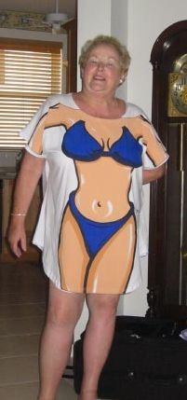
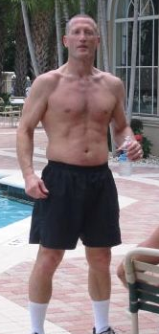
After returning to Debbie’s, Patty, Doug and Marge went their separate ways and Traci and I lay by the pool just in case the Caribbean sun hadn’t cooked every individual skin molecule. That night we went with Debbie to eat at a deli because we were so undernourished from the cruise. After dinner we had some of my homemade beer.

Friday May 9th. After a morning of breakfast and e-mail, Traci and I worked out at Debbie’s community gym and went to the pool. After a shvitzy afternoon in the sun, we went with Debbie and Marge to Kee Grill for some great food. At 70, Debbie was one of the youngest people in there. I swear the average age was 113. Meanwhile the temperature outside was 95° with 173% humidity.
Not bad for a 70-year-old.
Mr. Enchantment on land.

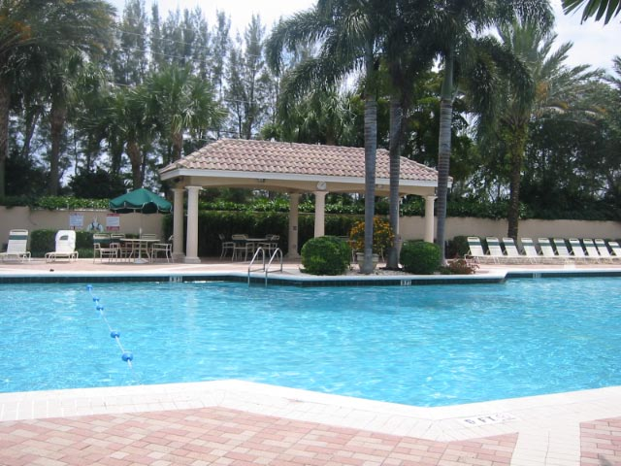
Saturday May 10th. Debbie, Marge, Traci and I spent several hours at the pool because skin cancer won’t happen without the sun. We drank homebrew and Sex on the Beach (OJ, peach schnapps and vodka). Then came the saddest part of the trip: leaving. Marge drove Traci and me to the airport and we returned to Maryland where it was in the 50s and cloudy and we could see our breath.

Afterword

Everything you just read is true, except the parts I made up. We had the time of our lives, and we can’t wait to do it all again when Debbie turns 80.

Note that the correct term is “chaise longue”, not “chaise lounge”.

